

The First National Conference on
Green Process Engineering and
Environmental Technologies.
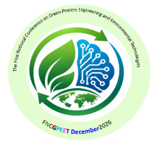

FNCGPEET December 2026

Abstract

Presentation of Abstracts
The abstract mast not exceed 300 words
Summary on A4 page, with 2.5 cm margins (top, bottom, right, left).
- Names of authors: Police 12, the name of the communicator must be underlined.
- Author affiliation: font 11 italic.
- Text should be written in Times New Roman, font12, single spacing.
- Keywords at the bottom of the summary, (5maximum)
- Languages: French or English.

